

**Home access of Adobe Applications**

Our current Adobe/CCPS licensing agreement allows you to install and access the entire Adobe Creative Cloud software suite on a home computer, as long as you are actively employed at CCPS (or currently enrolled as a student). Follow the instructions below to install and access the Creative Cloud applications on your computer at home:

1. Open [https:/www.adobe.com/](https://www.adobe.com/) in a web browser, and click on Sign in in the top right hand corner of the screen:

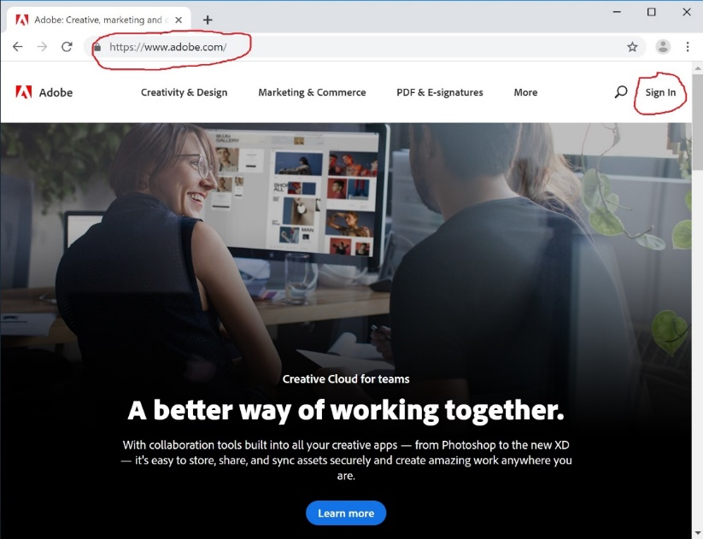

1. You will be directed to login with your Adobe ID. Enter in your CCPS E-Mail address into the username field:
   1. **Teachers**: [Username@collierschools.com](mailto:Username@collierschools.com) (example krausce@collierschools.com)
   2. **Students**: [StudentID@collierschools.com](mailto:StudentID@collierschools.com) (example 333333@collierschools.com)

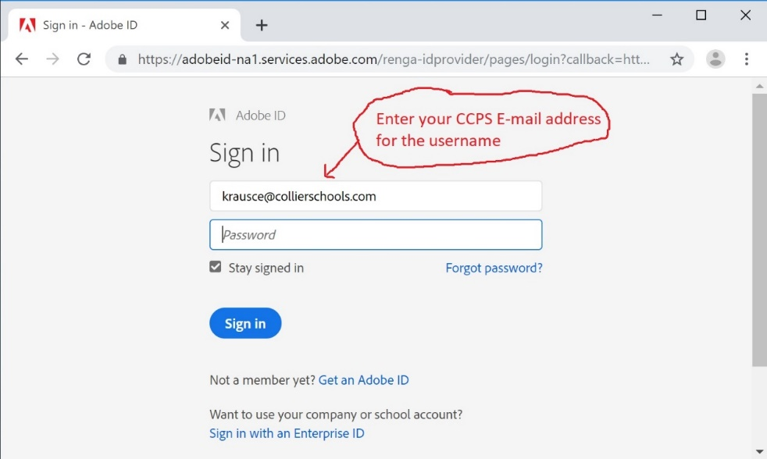

1. You will be redirected to a second login prompt. Enter in your username and password (as if you were logging into a CCPS computer) and click Sign in:

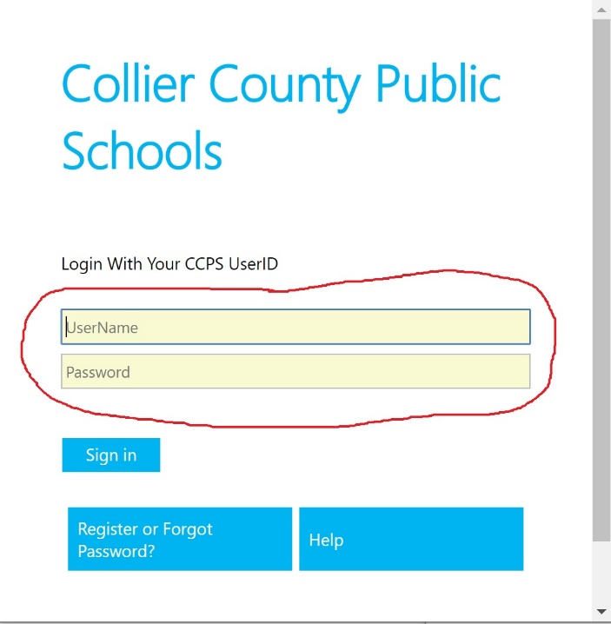

Note: on this screen **do not** add @collierschools.com after your username

1. Once logged into the Adobe website, Click **Desktop Downloads** as shown below:

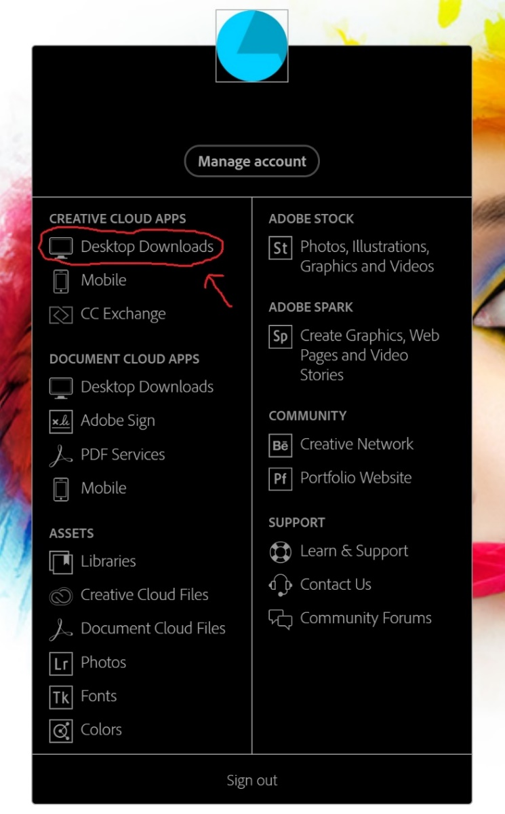

1. On the next screen, click on the **Download** button under the Adobe Creative Cloud option:

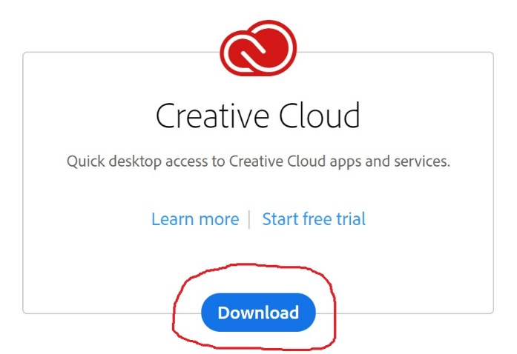

1. Download and Install the Adobe Creative Cloud Desktop Application Software on your computer. Once you install and launch the software, you will need to sign in one more time (Using the same steps 2-3 in this document). Once logged into the Desktop App, click on the Apps tab and then Install/Open any applications that you would like to use:

