

**Adobe Login Instructions for District Computers**

**2019 Updated Information**

**What is changing?** Adobe has recently updated its licensing to require a user specific license. This will provide the following benefits:

* Ability to access and leverage additional Creative Cloud Apps such as Adobe XD, Lightroom CC, and Adobe Dimension
* Access to Adobe Cloud Services such as Cloud Libraries, Cloud Collaboration with Team Projects, and font collections from Adobe Fonts
* Access to all Adobe Creative Cloud Applications at home (using personal devices)
  + Students
  + Teachers
  + Faculty
  + Administrators

In order to provide these benefits to Students, Teachers, and Staff, there are a few changes in the way that the Adobe software applications are accessed from CCPS Computers. When launching an Adobe software product (Such as Adobe Acrobat Pro, Photoshop, Premiere/etc), the following screen may appear. **This is normal and should only prompt for a sign-in once if you are a Teacher or Administrator.** Click on the “Sign In Now” button and follow the steps below in order to proceed:

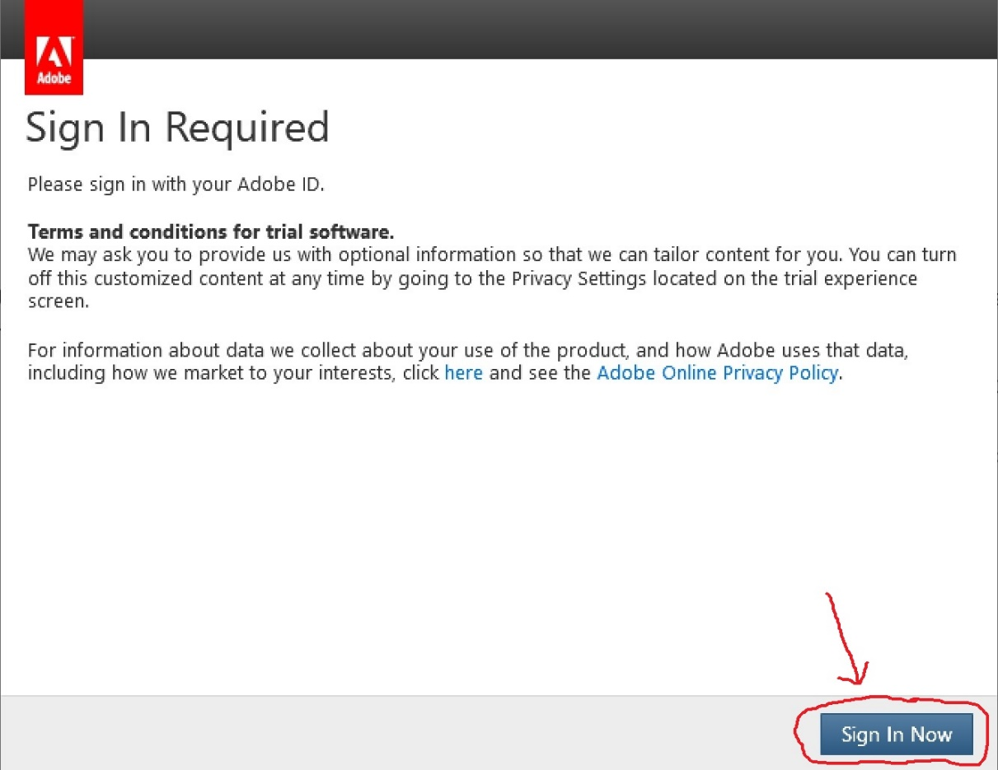

1. You will be directed to login with your Adobe ID. Enter in your CCPS E-Mail address into the username field:
   1. **Teachers**: [Username@collierschools.com](mailto:Username@collierschools.com) (example krausce@collierschools.com)
   2. **Students**: [StudentID@collierschools.com](mailto:StudentID@collierschools.com) (example 333333@collierschools.com)

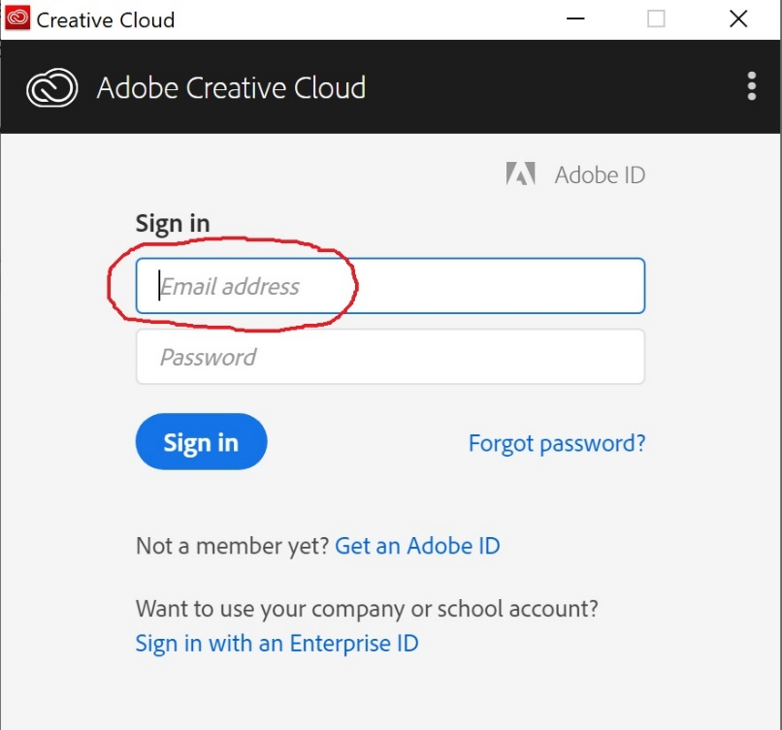

1. You may be redirected to a second login prompt. Enter in your username and password (as if you were logging into a CCPS computer) and click Sign in to continue:

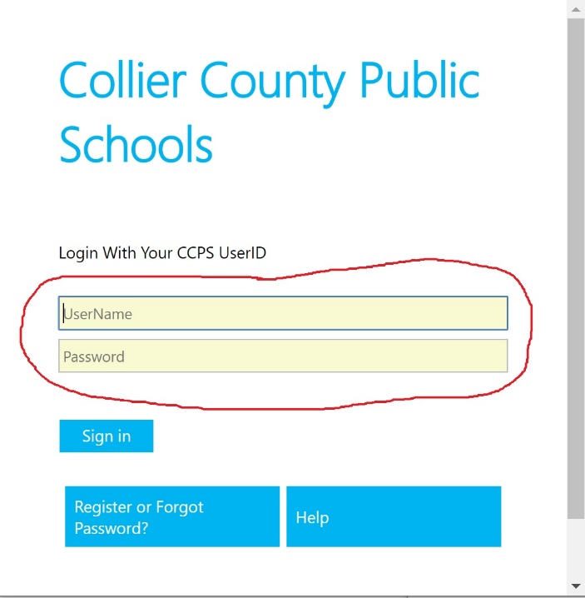

Note: on this screen **do not** add @collierschools.com after your username